**PEARSON HND**

**IN COMPUTING (LEVEL 4)**

**PRACTICE**

**PROFESSIONAL**

**MOHAMMED MOHAMME ISLAM**

**DR. Mahmoud Saed Alkhouli**

**ALDAR ACADEMY**

GARHOUD

056 22 373 56, mohammedmohammedislam12@gmail.com



Table of Contents

**Introduction** 5

**Understanding Communication** 5

**Types of Communication** 5

**Exploring 4 Types of Communication** 6

**Importance of Each Communication Type** 6

**Characteristics of Informal Language** 7

**Definition of Formal Dialogue** 8

**Comparing Informal and Formal Dialogue** 8

**Casual and Spontaneous Nature of Informal Dialogue** 8

**Structured and Conventional Characteristics of Formal Dialogue** 8

**The Role of Emotion in Effective Communication** 8

**Emphasis on Empathy in Communication** 8

**Active Listening in Communication** 9

**Definition and Importance of Active Listening** 9

**Techniques for Effective Active Listening** 9

**Barriers to Effective Communication** 9

**Identifying Common Barriers** 9

**Strategies to Overcome Barriers** 9

**Improving Communication Skills** 9

**Importance of Continuous Improvement** 10

**Tips for Enhancing Communication Skills** 10

**The Impact of Technology on Communication** 10

**Positive and Negative Effects** 10

**Navigating Digital Communication Challenges** 10

**Cultural Considerations in Communication** 10

**Understanding Cultural Differences** 10

**Importance of Cultural Sensitivity in Communication** 11

**Interpersonal Skills** 11

**Understanding Interpersonal Skills** 11

**Soft Skills** 11

**Personal Effectiveness** 12

**Working With Others:** 12

**Use of Initiative** 12

**Negotiating Skills** 12

**Assertiveness Skills** 13

**Social Skills** 13

**Team-Building Activities** 13

**Day 2: Practical Application and Reflection** 15

**Tow days training schodule** 16

**Tow days of training schodule** **gantt chart** 17

**Time Management** 20

**Understanding Time Management Skills** 20

**Prioritizing Workloads** 20

**Setting Objectives** 20

**Using Time Effectively** 21

**Making and Keeping Appointments** 21

**Planning and Scheduling Tasks** 21

**Mastering Problem-Solving: A Tale of Event Design and Delivery** 22

**Understanding Problem-Solving Techniques** 22

**1. Identifying the Problems** 22

**2. Problem Analysis and Clarification** 23

**3. Identifying Possible Outcomes** 23

**4. Problem-Solving Tools and Methods** 23

**Execution and Evaluation** 23

**Navigating the Terrain of Team Dynamics: A Crucial Element in Group Success** 25

**The Importance of Teamwork** 25

**Dynamics in Team Success and Failure** 26

**Personal Reflection on Team Contribution** 26

**Nurturing Professional Growth: The Essence of Continuing Professional Development (CPD)** 28

**The Imperative of Continuing Professional Development (CPD)** 28

**CPD and Its Contribution to Individual Learning and Motivation** 28

**Motivational Theories and Their Impact on Workplace Performance** 29

**Crafting a Development Plan for Future Goals** 29

**The Role of CPD and Development Planning in Building Motivation** 30

**Evaluating Evidence Criteria for Effective CPD** 30

**Introduction**

Effective communication goes beyond the mere exchange of information. It is a nuanced process that involves understanding the emotions and intentions underlying the information shared. While clarity in conveying messages is crucial, true effectiveness lies in the ability to listen actively, grasping the full meaning of what is communicated and making the other person feel heard and understood.[1]

**Understanding Communication**

Communication, at its core, is a two-way process involving the sending and receiving of messages through verbal and non-verbal methods. It serves as a conduit for expressing thoughts, opinions, and ideas, with the ultimate goal of building mutual understanding.[1]

**Types of Communication**

**Written Communication:** Any exchange of written messages between two or more individuals falls under this category. It includes emails, letters, and any form of documented communication.[1]

**Verbal Communication:** Encompassing both written and spoken language, verbal communication is a dynamic form involving direct interaction through words.[1]

**Non-verbal Communication:** This type involves the transfer of information through body language, facial expressions, gestures, and created space, often conveying emotions that words alone may not capture.[1]

**Visual Communication:** Utilizing visual elements, this form aims to convey messages, inspire change, or evoke emotions through graphics, images, and other visual aids.[1]

**Exploring 4 Types of Communication**

Let's delve deeper into each type to understand their nuances and significance in effective communication.[1]

**Written Communication**

Written communication holds a distinctive place in conveying information. Be it formal reports or casual messages, the written word can leave a lasting impact.[1]

**Verbal Communication**

The power of spoken words cannot be understated. Verbal communication, whether in a formal presentation or a casual conversation, allows for immediate interaction and clarification.[1]

**Non-verbal Communication**

Often, what is left unsaid carries immense weight. Non-verbal cues such as body language and facial expressions contribute significantly to the richness of communication.[1]

**Visual Communication**

The adage "a picture is worth a thousand words" rings true in visual communication. Whether through infographics or videos, visuals enhance the understanding and retention of information.[1]

**Importance of Each Communication Type**

Understanding the significance of each type is crucial for effective communication strategies.[1]

**Highlighting the Significance of Written Communication**

Written communication provides a tangible record, ensuring clarity and reducing the likelihood of misinterpretation.[1]

**Emphasizing the Power of Verbal Communication**

The immediacy of verbal communication fosters real-time engagement, allowing for questions, clarifications, and a deeper understanding.[1]

**Understanding the Nuances of Non-verbal Communication**

Non-verbal cues add layers to communication, expressing emotions and intentions that words alone may not convey.[1]

**Appreciating the Impact of Visual Communication**

Visual elements enhance engagement and understanding, catering to diverse learning preferences and communication styles.[1]

**Distinguishing Between Formal and Informal Dialogue**

Communication styles vary, and recognizing the distinctions between formal and informal dialogue is essential.[2]

**Definition of Informal Dialogue**

Informal dialogue is characterized by its casual and spontaneous nature, often occurring between individuals with existing bonds.[2]

**Characteristics of Informal Language**

The use of colloquialisms and relaxed tone are hallmarks of informal language, promoting a sense of familiarity.[2]

**Definition of Formal Dialogue**

Conversely, formal dialogue transpires between individuals who are strangers or lack pre-existing relationships.[2]

**Comparing Informal and Formal Dialogue**

While informal dialogue fosters a sense of connection, formal dialogue adheres to structured and conventional communication norms.[2]

**Casual and Spontaneous Nature of Informal Dialogue**

Informal conversations often flow effortlessly, reflecting the ease and comfort between participants.[2]

**Structured and Conventional Characteristics of Formal Dialogue**

Conversely, formal dialogue maintains a structured approach, adhering to established etiquette and communication norms.[2]

**The Role of Emotion in Effective Communication**

Emotion serves as a vital element in effective communication, fostering a deeper connection between individuals.[2]

**Emphasis on Empathy in Communication**

Empathy, the ability to understand and share the feelings of another, enhances communication by acknowledging emotions and perspectives.[2]

**Active Listening in Communication**

Active listening is a fundamental skill that complements effective communication.[2]

**Definition and Importance of Active Listening**

Active listening involves fully concentrating, understanding, responding, and remembering what is being communicated—a key factor in building strong relationships.[2]

**Techniques for Effective Active Listening**

Practicing techniques such as paraphrasing, summarizing, and asking clarifying questions enhances active listening skills.[2]

**Barriers to Effective Communication**

Identifying and overcoming barriers is essential for fostering clear and meaningful communication.[2]

**Identifying Common Barriers**

Common barriers include misunderstandings, lack of clarity, and distractions, hindering effective communication.[2]

**Strategies to Overcome Barriers**

Strategies such as clarity in expression, active listening, and seeking feedback aid in overcoming communication barriers.[2]

**Improving Communication Skills**

Continuous improvement is integral to enhancing communication skills.[2]

**Importance of Continuous Improvement**

Adopting a growth mindset and seeking opportunities for improvement contribute to becoming a more effective communicator.[2]

**Tips for Enhancing Communication Skills**

Practical tips, including practicing mindfulness, seeking feedback, and participating in communication workshops, can significantly enhance communication skills.[2]

**The Impact of Technology on Communication**

In the digital age, technology plays a pivotal role in shaping communication dynamics.[2]

**Positive and Negative Effects**

While technology facilitates instant communication, it can also pose challenges such as misinterpretation and information overload.[2]

**Navigating Digital Communication Challenges**

Being mindful of digital communication nuances and utilizing tools effectively helps navigate the challenges posed by technology.[2]

**Cultural Considerations in Communication**

Recognizing and respecting cultural differences is essential for effective cross-cultural communication.[2]

**Understanding Cultural Differences**

Cultural nuances impact communication styles, requiring sensitivity and adaptability.[2]

**Importance of Cultural Sensitivity in Communication**

Cultural sensitivity fosters understanding, minimizes misunderstandings, and promotes inclusive communication.

effective communication is a multifaceted skill that involves understanding emotions, active listening, and navigating various communication types. By recognizing the nuances of formal and informal dialogue, embracing emotion, practicing active listening, and overcoming barriers, individuals can enhance their communication skills. The impact of technology and cultural considerations further emphasizes the need for adaptability in the ever-evolving landscape of communication.[2]

**Interpersonal Skills**

Interpersonal skills, often referred to as people skills, social skills, or social intelligence, form a critical aspect of personal and professional success. Mastering these skills involves reading signals from others accurately and responding effectively. In this article, we'll explore the significance of interpersonal skills, their role as soft skills, and how they contribute to personal effectiveness, teamwork, the use of initiative, negotiating, and assertiveness.[3]

**Understanding Interpersonal Skills**

Interpersonal skills encompass the ability to navigate social interactions successfully. These skills go beyond verbal communication, extending to reading non-verbal cues and interpreting them accurately. A person with strong interpersonal skills can form meaningful connections, build rapport, and foster positive relationships both in personal and professional settings. [3]

**Soft Skills**

Soft skills, a broader category that includes interpersonal skills, are integral to personal and professional development. These encompass communication skills, listening skills, time management, problem-solving, leadership, and empathy. The versatility of soft skills makes them essential in various aspects of life, from the workplace to personal relationships. [3]

**Personal Effectiveness**

At its core, personal effectiveness is about optimizing one's capabilities. It involves self-awareness, self-regulation, and a commitment to continuous improvement. Mastering interpersonal skills contributes significantly to personal effectiveness by enhancing communication, building relationships, and navigating social dynamics with finesse. [3]

**Working With Others:**

The ability to work effectively with others is a hallmark of strong interpersonal skills. Collaboration, cooperation, and conflict resolution are crucial components of achieving shared goals within a team or organization. Understanding and aligning with the culture, rules, and values of the group contribute to successful teamwork. [3]

**Use of Initiative**

Initiative is the proactive approach of taking charge and making things happen. Embracing initiative in the context of interpersonal skills means actively seeking opportunities to engage with others, express ideas, and contribute to collective success. The benefits range from personal growth to gaining the respect of peers and management. [3]

**Negotiating Skills**

Negotiating is a strategic dialogue where parties aim for mutually beneficial outcomes. Interpersonal skills play a pivotal role in negotiations, as effective communication, empathy, and understanding are key to reaching compromises that satisfy all parties involved. Mastering negotiating skills enhances one's ability to navigate complex situations successfully. [3]

**Assertiveness Skills**

Assertiveness is a cornerstone of effective communication. It involves expressing oneself honestly and respectfully. Whether it's asking someone on a date, approaching a teacher with a question, or excelling in a job or college interview, assertiveness empowers individuals to communicate with confidence and authenticity. [3]

**Social Skills**

Social skills encompass the everyday tools we use to interact and communicate with others. From verbal communication to non-verbal cues such as speech, gesture, facial expression, and body language, these skills are vital for building connections, fostering relationships, and navigating the complexities of social interactions.

developing and honing interpersonal skills is a journey towards personal and professional success. From mastering soft skills and enhancing personal effectiveness to thriving in teamwork, taking initiative, negotiating effectively, and communicating assertively, these skills form the foundation of a well-rounded individual. As you embark on this journey, remember that each interaction is an opportunity to refine your interpersonal skills and pave the way for a more fulfilling and successful life. [3]

**Team-Building Activities**

Embark on a journey of team cohesion with our curated team-building activities at Cognizant Pvt Ltd. From engaging icebreakers that foster camaraderie to collaborative workshops that strengthen communication, our activities are designed to unite and inspire. Explore the power of teamwork through interactive challenges, problem-solving exercises, and activities that promote mutual understanding. Whether you're looking to enhance communication, boost morale, or simply create a positive team dynamic, our team-building activities are tailored to meet your specific goals. Join us in fostering a more connected and effective team at Cognizant Pvt Ltd.

**Day 1: Foundation and Skill Development**

**9:00 AM - 9:30 AM: Registration and Welcome**

* Registration process
* Welcome address and introduction to the workshop

**9:30 AM - 10:30 AM: Icebreaker and Team Building**

* Engaging icebreaker activities
* Team-building exercises to foster collaboration

**10:30 AM - 11:00 AM: Overview of Training Objectives**

* Presentation on the goals and objectives of the workshop
* Discussion on the importance of the training for individual and team growth

**11:00 AM - 12:30 PM: Session 1 - Understanding Company Values and Culture**

* Presentation on company values and culture
* Interactive discussions and case studies

**12:30 PM - 1:30 PM: Lunch Break**

**1:30 PM - 3:00 PM: Session 2 - Effective Communication Skills**

* Workshop on communication styles and techniques
* Role-playing exercises and group discussions

**3:00 PM - 3:30 PM: Coffee Break**

**3:30 PM - 5:00 PM: Session 3 - Time Management and Productivity**

* Time management strategies
* Practical tips and tools for improving productivity

**5:00 PM - 5:30 PM: Recap and Q&A**

* Summary of the day's sessions
* Question and answer session

**Day 2: Practical Application and Reflection**

**9:00 AM - 9:30 AM: Recap of Day 1**

* Brief overview of the previous day's key points
* Clarifications on any questions or concerns

**9:30 AM - 11:00 AM: Session 4 - Conflict Resolution and Team Collaboration**

* Workshop on identifying and resolving conflicts
* Team-building activities to strengthen collaboration

**11:00 AM - 11:30 AM: Coffee Break**

**11:30 AM - 1:00 PM: Session 5 - Goal Setting and Professional Development**

* Setting personal and professional goals
* Creating action plans for continuous improvement

**1:00 PM - 2:00 PM: Lunch Break**

**2:00 PM - 3:30 PM: Session 6 - Leadership Skills and Decision Making**

* Exploring leadership qualities
* Decision-making exercises and case studies

**3:30 PM - 4:00 PM: Coffee Break**

**4:00 PM - 5:00 PM: Interactive Workshops and Group Activities**

* Small group activities related to the day's topics
* Practical application of learned skills

**5:00 PM - 5:30 PM: Closing Remarks and Certificates**

* Acknowledgment of participants
* Distribution of certificates
* Closing remarks and gratitude

**Tow days training schodule**

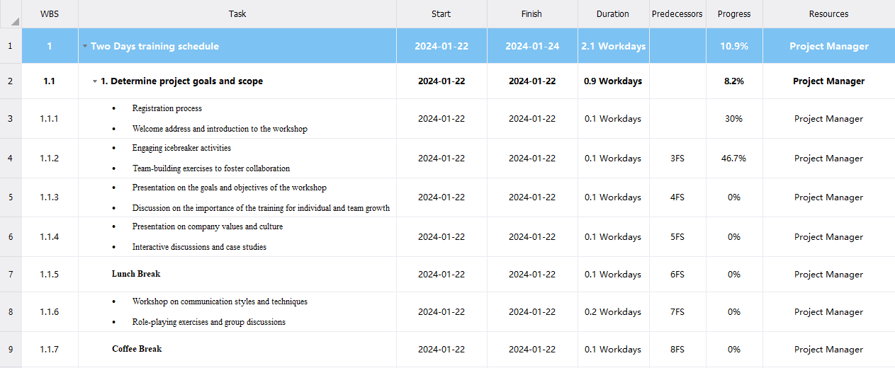

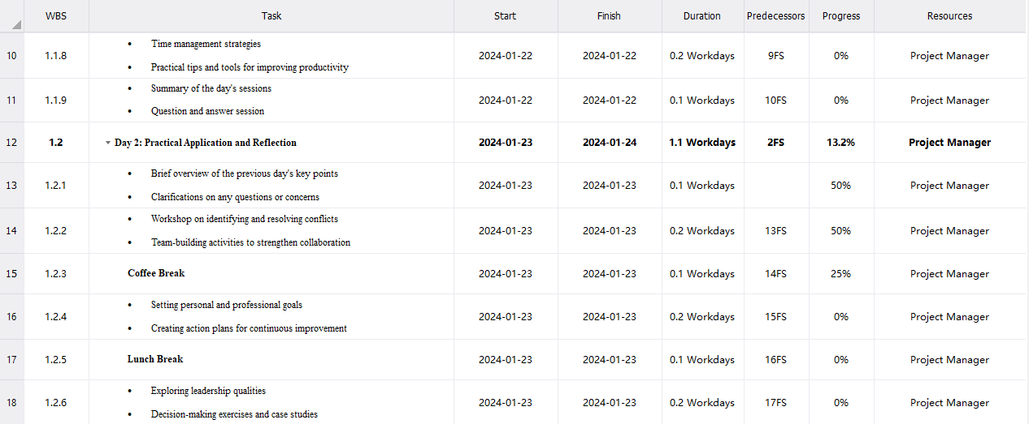

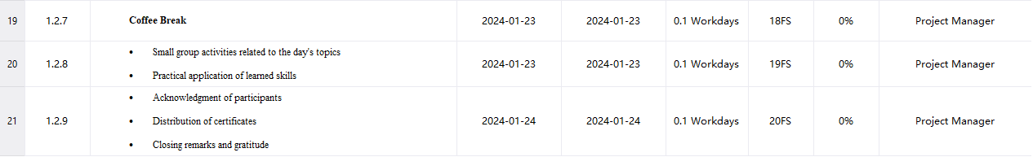

**Tow days of training schodule** **gantt chart**

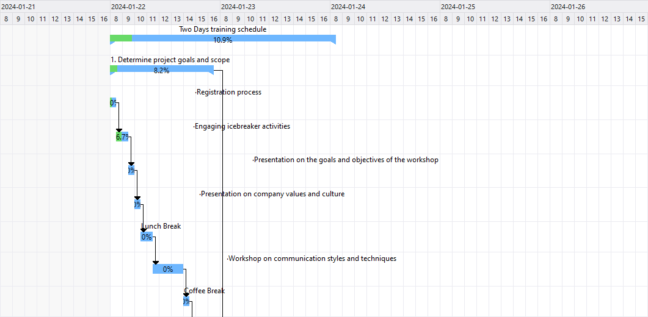



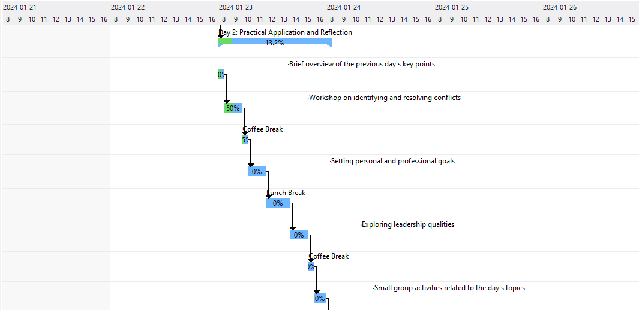



**First day of training**

The two days training program will be conducted on Monday and Tuesday in Cognizant Pvt Ltd, Dubai. The time duration for this session is 8 and a half hours, from 9am-5:30pm. In first half hour of first day, there will be an registration process and introduction to the workshop . After the completion of introduction part, Engaging icebreaker activities and Team-building exercises to foster collaborationwill be provided so that they can know and cooperate with each other till 10:30am. Then, An hour and a half is scheduled for each the Word Presentation on the goals and objectives of the workshop and Discussion on the importance of the training for individual and team growth, Presentation on company values and culture and Interactive discussions and case studies. After that there will be a lunch break time from 12:30pm 1:30pm. In between the interval of 1:30 pm and 3 pm, there will be workshop on communication styles and techniques and role-playing exercises and group discussions.Along with that employees will also get opportunity for discussion on time management strategies and practical tips and tools to improve productivity. At last, before ending our first day training program there will be one group discussion session for an half hour to explore the 10 knowledge gain in a single day and to clear their doubts related to today's topic. In this way the first day will be completed.

**Second Day of Training**

The next day will be started in same venue and at same duration with brief overview of the previous day's key points and clarifications on any questions or concerns for about half hour till 9:30am. Then one and half hour will be provided on workshop on identifying and resolving conflicts and team-building activities to strengthen collaboration. The coffee break time will be bit earlier in second day than first day program, between 11-11:30pm. After that, one and half hour will be utilized for setting personal and professional goals and creating action plans for continuous improvement.After that there will be a Lunch break time from 1:00pm 2:00pm. After that, one and half hour will be utilized for exploring leadership qualities and decision-making exercises and case studies. Following that, half hour will be dedicated to Coffee Break 3:30 PM - 4:00 PM. After that, one hour will be utilized for Small group activities related to the day's topics and Practical application of learned skills from 4:00 PM - 5:00 PM. Then, in the last 30 minutes, our Training and Development Manager will give short speech to conclude the program and Acknowledgment of participants, Distribution of certificates, Closing remarks and gratitude, also receive feedbacks from students so that we could conduct more effective plans and programs in upcoming days. In this way our two days training schedule will be completed.

**Conclusion:** Our event scheduled is well planned, managed and organized as I include number of activities to develop their professional development. All the trainings included in the program are time specific. I have auspiciously arranged this two days training event targeting audiences to a large extent. I have applied my time management skills and interpersonal skills to make this event effective. The training programs included in this event are fully beneficial for the employees.

**Time Management**

Time management is a crucial professional skill that can significantly impact one's career trajectory. Effectively organizing tasks, prioritizing workloads, and setting objectives are key components of this skill set. In this article, we'll explore the importance of time management skills, the power of prioritization, the role of setting objectives, and the overall impact on personal and professional success.[4]

**Understanding Time Management Skills**

Managing time effectively is more than just a task; it's a skill that professionals need to develop for sustained success. This skill involves organizing daily tasks, meeting deadlines, and communicating progress efficiently to supervisors and colleagues. Strong time-management skills serve as a foundation for accomplishing key goals and advancing in one's career. [4]

**Prioritizing Workloads**

Prioritization is a powerful skill that empowers individuals to take control of their workflow and optimize productivity. Breaking down workloads into manageable chunks and setting priorities help break the cycle of missed deadlines, last-minute rushes, and procrastination. By focusing on high-priority tasks first, professionals can ensure a more structured and effective approach to their work. [4]

**Setting Objectives**

Setting objectives is the cornerstone of effective planning. Objectives define what an organization aims to achieve, providing a clear direction for operations. This process begins by establishing specific and measurable goals for the organization as a whole, with individual departments aligning their objectives within this framework. Clear objectives create a roadmap for success and guide efforts toward achieving organizational goals. [4]

**Using Time Effectively**

Effective time management is crucial in both personal and professional contexts. Beyond meeting deadlines, it plays a vital role in reducing stress, enhancing productivity, and fostering a balanced and fulfilling life. Making informed choices about how time is spent, minimizing distractions, and organizing tasks based on importance and deadlines are key aspects of mastering time effectively.

By making conscious decisions about time allocation, individuals can strike a harmonious balance between work, leisure, and personal pursuits. This skill not only enhances efficiency but also contributes to overall well-being. [4]

**Making and Keeping Appointments**

Making and keeping appointments showcase respect for others' time and reflect a commitment to punctuality. Scheduled meetings, when adhered to, start and end on time, demonstrating professionalism and reliability. This practice ensures that collaborative efforts are well-coordinated, contributing to a smooth and efficient work environment. [4]

**Planning and Scheduling Tasks**

In project management, scheduling is a meticulous process that defines a project in detail and creates a plan for completion. Establishing a project schedule with clear timelines and deadlines for each task provides visibility for team members. This clarity keeps everyone involved on track, fosters accountability, and ensures that projects progress seamlessly toward their goals. [4]

mastering time management is a gateway to professional success. Whether through effective prioritization, setting clear objectives, utilizing time wisely, respecting others' time through punctuality, or meticulous planning in project management, these skills contribute to a well-rounded and accomplished professional. By honing these capabilities, individuals can navigate the demands of their careers, meet objectives, and lead a more fulfilling and balanced life. [4]

**Mastering Problem-Solving: A Tale of Event Design and Delivery**

Embarking on the journey of organizing a two-day training event is no small feat. Challenges lurk in the shadows, ready to disrupt the seamless flow of activities. In this narrative, we delve into the world of problem-solving techniques and their pivotal role in the design and delivery of a successful event. [4]

**Understanding Problem-Solving Techniques**

Problem-solving abilities are the cornerstone of effective event management. The capability to detect issues, generate and evaluate ideas, and implement optimal solutions defines a problem-solving expert. Such individuals are not just self-starters but also collaborative team players, proactively identifying the crux of an issue and working with others to explore a multitude of alternatives before charting the course forward. Critical thinking and analytical skills are indispensable for resolving issues, and in the dynamic realm of event planning, everyone benefits from possessing robust problem-solving abilities. [4]

**Problem Solving Techniques Applied**

As the architect of a two-day training event, I encountered a myriad of challenges, ranging from bad weather conditions to electrical issues. The application of problem-solving techniques became imperative to ensure the seamless execution of the event. [4]

**1. Identifying the Problems**

The first step in problem-solving is recognizing the issues at hand. While planning and scheduling the training event, I engaged in analytical thinking to foresee potential challenges. Two major problems emerged: the looming threat of load shedding and the vulnerability of electrical devices. [4]

**2. Problem Analysis and Clarification**

Problem analysis involves delving into the negative aspects of a situation and understanding its root causes. Analyzing the issues of load shedding and potential device failures required a close examination of the present situation in the UAE. Anticipating electricity cutoff during the event and the unreliability of electrical devices due to uncertainties such as high voltage and short circuits led to a crucial realization. [4]

**3. Identifying Possible Outcomes**

Having clarified the problems, the next step was to identify potential solutions and select the most appropriate ones. For the load shedding issue, two possible outcomes were considered: purchasing an inverter or renting a generator. Considering the budget constraints and the nature of the event, renting a generator emerged as the optimal choice. Additionally, the prospect of purchasing an extra projector was entertained to mitigate any issues during the event. [4]

**4. Problem-Solving Tools and Methods**

Implementing solutions involves planning, execution, and post-execution evaluation. For the load shedding issue, a generator was rented for two days, and a new projector was purchased as a preventive measure. A budget of 3000 was allocated for the generator, and 6000 for the projector. [4]

**Execution and Evaluation**

The first day of the training event witnessed a one-hour load shedding between 1 pm and 3 pm. Fortunately, with a well-executed plan, the generator provided uninterrupted power during the break, ensuring a smooth continuation of the event. The projector, however, succumbed to the continuous workload on the first day, prompting a seamless replacement with the newly acquired one on the second day. Evaluation of the event's success revealed that despite the additional expense of 9000, the strategic management of the generator and projector proved instrumental in overcoming potential disruptions.

In conclusion, the journey of organizing a two-day training event unveiled the power of critical thinking and problem-solving techniques. By anticipating challenges, identifying problems, and implementing effective solutions, the event not only navigated potential pitfalls but also concluded successfully without interruptions. The art of problem-solving, when applied thoughtfully, transforms challenges into opportunities and ensures the seamless delivery of impactful events. [4]

|  |  |  |  |  |
| --- | --- | --- | --- | --- |
| **Problem**  **Identify** | **Problem**  **Analyse** | **Possible**  **solutions** | **implementation plan** | **Evaluation** |
| Electrical issues | Electrical problems can disrupt events, posing safety risks. Power failures, equipment malfunctions, or insufficient capacity require careful analysis. | Hire an electrician for thorough pre-event checks. | Schedule electrician checks well in advance. | Verify solutions through pre-event testing. |
| Not enough seats | Insufficient seating can hinder attendee comfort and event experience. Identifying causes and viable solutions is crucial. | Rent more chairs or benches. | Evaluate seating against expected attendance. | Assess effectiveness of added seating. |
| Fire | Fires during events pose severe threats. Understanding causes and preventive measures is crucial. | Conduct a pre-event fire risk assessment. | Hire professionals for a thorough assessment. | Regularly reassess fire risks. |

|  |  |
| --- | --- |
| **Advantages** | **disadvantages** |
| **Diverse Perspectives** | **Conflict and Disagreements** |
| **Enhanced Creativity** | **Dependency on Others** |
| **Efficient Problem Solving** | **Groupthink** |
| **Increased Productivity** | **Coordination Challenges** |

**Navigating the Terrain of Team Dynamics: A Crucial Element in Group Success**

Collaboration is the heartbeat of progress, and nowhere is this more evident than in the dynamics of working within a team. Whether in the corporate world, academic settings, or community initiatives, the impact of team dynamics can shape the trajectory of success or failure in achieving collective goals.[5]

**The Importance of Teamwork**

**1. Shared Expertise and Skills**

In the complex landscape of modern challenges, no individual possesses a monopoly on knowledge or skills. Teams bring together a diverse range of talents, experiences, and perspectives, creating a synergy that far surpasses what any single person can achieve. The pooling of resources leads to comprehensive problem-solving and innovative solutions. [5]

**2. Enhanced Creativity and Innovation**

Team environments foster creativity through the collision of different ideas. The synergy of minds working collectively often sparks innovative solutions that might not emerge in individual settings. The dynamic exchange of thoughts, viewpoints, and experiences generates a fertile ground for creativity to flourish. [5]

**3. Increased Efficiency and Productivity**

Dividing tasks based on individual strengths streamlines workflow and boosts efficiency. While one team member may excel in analysis, another may thrive in execution. This division of labor ensures that each component of the task is handled by the most capable individual, resulting in heightened productivity. [5]

**4. Mutual Support and Motivation**

In a team, individuals find support in moments of challenge or uncertainty. The collective motivation derived from shared goals and a sense of belonging propels team members through obstacles. The camaraderie and encouragement within a team create a positive environment, enhancing individual and group morale. [5]

**Dynamics in Team Success and Failure**

**1. Roles within the Team**

Understanding and defining roles within a team is pivotal. Every member contributes a unique set of skills, and assigning roles based on these strengths ensures a well-rounded team. A good mix of leadership, creativity, execution, and analysis is essential for a team to function harmoniously. [5]

**2. Communication and Collaboration**

Effective communication is the lifeblood of team dynamics. Miscommunication or lack of communication can lead to misunderstandings and hinder progress. Collaborative platforms, regular meetings, and open channels for discussion are vital to maintaining a healthy flow of information within the team. [5]

**3. Conflict Resolution**

Conflict within a team is not inherently negative; it's a natural consequence of diverse perspectives. However, the key lies in resolving conflicts constructively. Teams that navigate conflicts with empathy, active listening, and a focus on solutions emerge stronger and more resilient. [5]

**Personal Reflection on Team Contribution**

Analyzing one's role and contribution within a group scenario is a journey of self-awareness. It involves recognizing strengths, acknowledging areas for improvement, and understanding how individual contributions align with the team's goals. Some key aspects of self-evaluation include: [5]

**1. Self-Awareness**

Understanding personal strengths and weaknesses contributes to effective teamwork. Recognizing how one's skills complement or overlap with others fosters a collaborative environment. [5]

**2. Adaptability**

Team dynamics are fluid, requiring adaptability. Reflecting on how well one adjusts to evolving roles or unexpected challenges provides insight into personal flexibility within a team setting. [5]

**3. Communication Skills**

Effective communication is a linchpin in team success. Assessing one's communication style and considering how well it aligns with the team's needs sheds light on areas for improvement. [5]

**4. Conflict Resolution Skills**

Examining personal approaches to conflict resolution within a team setting allows for growth. Being open to feedback and learning from disagreements contributes to individual and team development.

The importance of team dynamics in achieving collective goals cannot be overstated. The collaboration of individuals with diverse skills and perspectives generates a powerhouse of innovation and efficiency. Success or failure within a team hinges on effective communication, well-defined roles, and the ability to navigate conflicts constructively. Engaging in thoughtful self-reflection adds a layer of personal growth, contributing to the overall health and success of the team. As we navigate the complex terrain of collaborative endeavors, the echoes of successful teamwork resound in the achievements and milestones attained collectively. [5]

**Our team,**

dedicated to organizing a training session for individuals interested in website creation, has been structured into three groups to efficiently manage the event. I serve as the team leader and organizer, responsible for the overall coordination, pre-event planning, and executing key roles during the event.

**Group Structure:**

Group A: Event Organizers and Officials - Welcoming Visitors

|  |  |  |
| --- | --- | --- |
| **M. N** | **Member name** | **Member work** |
| **3** | **Omer Yacine** | * **Pre-Event Planning** * **Visitor Registration** |
| **4** | **Maryam Mohammed** | * **Information Desk Setup** * **Coordination with Officials** |
| **5** | **Hareb Hamed** | * **Welcoming Committee** * **Feedback Collection** |

Group B: Responsible for the Stage and Educational Lectures

|  |  |  |
| --- | --- | --- |
| **M. N** | **Member name** | **Member work** |
| **1** | **Salem Ali** | * **Stage Setup** * **Audiovisual Equipment** |
| **2** | **Sara Majed** | * **Q&A Sessions** |

|  |  |  |
| --- | --- | --- |
| **M. N** | **Member name** | **Member work** |
| **6** | **Anas Noor** | * **Electrical Setup** |
| **7** | **Abdullah Ammar** | * **General Supervision** |
| **3** | **Mohammed Hamdan** | * **Emergency Preparedness** |

Group C: Responsible Behind the Scenes - Electrical Duties and General Supervision

**Team Leader Responsibilities:**

As the team leader, I play a crucial role in the successful execution of the event. My responsibilities include:

Distributing tasks among team members based on their skills and preferences.

Collaborating with all groups to ensure a cohesive and well-executed event.

Overseeing pre-event planning, visitor registration, and coordination with officials.

Managing stage setup, audiovisual equipment, and conducting Q&A sessions.

Supervising electrical setup, general event supervision, and ensuring emergency preparedness.

**Collaboration Approach:**

To ensure effective collaboration among team members and groups, we have adopted the following approach:

**Pre-Event:**

Regular team meetings to discuss progress, concerns, and align on tasks.

Open communication channels to encourage feedback and suggestions.

**On-Site:**

Clear communication channels between groups for real-time updates.

Deputy leader (Abdullah Ammar) overseeing overall operations.

**Post-Event:**

Comprehensive debriefing session to evaluate event success and identify areas for improvement.

Gathering feedback from each group to inform future event planning.

By leveraging the diverse skills of each team member and efficiently dividing responsibilities, we are confident in delivering an informative, engaging, and well-organized training session. The collaborative approach ensures the successful achievement of our engagement goals.

**Nurturing Professional Growth: The Essence of Continuing Professional Development (CPD)**

In the ever-evolving landscape of the professional world, the need for Continuing Professional Development (CPD) has become not just a choice but a necessity. This article explores the significance of CPD in the workplace and higher-level learning, delving into its role in individual learning, motivation, and the broader context of performance.[6]

**The Imperative of Continuing Professional Development (CPD)**

**1. Adaptability in a Changing Landscape**

In the contemporary workplace, change is the only constant. Technology evolves, industries transform, and new challenges emerge. CPD ensures that professionals stay abreast of industry trends, technological advancements, and evolving best practices. It fosters adaptability, equipping individuals to navigate change with confidence. [6]

**2. Enhanced Competence and Expertise**

CPD is a pathway to continuous learning, enabling professionals to deepen their knowledge and enhance their skills. Whether through workshops, conferences, or online courses, individuals can acquire new competencies that contribute to their expertise, making them more valuable contributors in their respective fields. [6]

**3. Career Advancement and Employability**

Stagnation is the enemy of career progression. CPD serves as a catalyst for career advancement, making individuals more marketable and increasing their employability. Employers value professionals who demonstrate a commitment to ongoing learning, making CPD a key factor in career growth. [6]

**CPD and Its Contribution to Individual Learning and Motivation**

**1. Empowering Personal Growth**

CPD is not just about professional skills; it's about personal growth. Engaging in continuous learning broadens perspectives, enhances critical thinking, and fosters a sense of intellectual curiosity. The satisfaction derived from personal growth is a potent motivator, driving individuals to pursue CPD opportunities eagerly. [6]

**2. Aligning Personal Goals with Professional Development**

CPD allows individuals to tailor their learning journeys to align with their personal and professional goals. This alignment creates a sense of purpose, transforming learning from a mere requirement to a fulfilling pursuit. The connection between CPD and personal aspirations acts as a powerful motivator. [6]

**Motivational Theories and Their Impact on Workplace Performance**

**1. Maslow's Hierarchy of Needs**

Maslow's theory posits that individuals are motivated by a hierarchy of needs, ranging from basic physiological requirements to self-actualization. CPD aligns with the higher levels of this hierarchy, addressing the needs for esteem and self-actualization by providing opportunities for achievement, recognition, and personal growth. [6]

**2. Herzberg's Two-Factor Theory**

Herzberg identified two sets of factors influencing motivation: hygiene factors (associated with job dissatisfaction) and motivators (linked to job satisfaction). CPD acts as a motivator by contributing to job enrichment, providing opportunities for skill development, and enhancing individuals' sense of achievement and recognition. [6]

**Crafting a Development Plan for Future Goals**

**1. Setting Clear Responsibilities**

A development plan begins with defining clear responsibilities. This involves understanding one's current role, identifying areas for improvement, and delineating the responsibilities that align with future goals. [6]

**2. Performance Objectives**

Performance objectives in a development plan should be SMART—Specific, Measurable, Achievable, Relevant, and Time-Bound. These objectives serve as benchmarks for progress and success in the pursuit of professional development. [6]

**3. Required Skills for Future Goals**

Identifying the skills necessary for future goals is central to a development plan. Whether technical, leadership, or soft skills, the plan should outline the acquisition and enhancement of skills essential for reaching desired career milestones. [6]

**The Role of CPD and Development Planning in Building Motivation**

CPD and development planning are intrinsically linked to motivation. The act of setting and pursuing personal and professional goals creates a sense of direction and purpose, serving as a motivational force. The progress made through CPD activities further reinforces a positive feedback loop, inspiring individuals to persist in their pursuit of excellence. [6]

**Evaluating Evidence Criteria for Effective CPD**

**1. Relevance to Career Goals**

Effective CPD aligns with individual career goals. The relevance of activities to professional aspirations is a critical criterion for evaluating their impact. [6]

**2. Demonstrable Application**

The application of CPD learning in the workplace is a tangible measure of its effectiveness. The ability to implement new knowledge and skills contributes to both individual growth and organizational success. [6]

**3. Feedback and Reflection**

Feedback and self-reflection play a crucial role in evaluating CPD. Regular assessments, peer reviews, and personal reflection help gauge the effectiveness of the learning journey. [6]

**Conclusion**

Continuing Professional Development (CPD) is not merely a checkbox on a professional's to-do list; it's a dynamic force driving growth, motivation, and success. Its role in individual learning, motivation, and performance is indisputable, shaping not only the careers of individuals but also the resilience and innovation of organizations. As professionals embark on their CPD journeys, they sow the seeds of progress, contributing not only to their own development but also to the ever-evolving tapestry of the professional landscape. [6]

[1] “Difference Between Good and Effective Communication.” Accessed: Jan. 15, 2024. [Online]. Available: https://www.some.education/blog/difference-between-communication-and-effective-communication

[2] “Formal and informal language,” University of Technology Sydney. Accessed: Jan. 15, 2024. [Online]. Available: https://www.uts.edu.au/current-students/support/helps/self-help-resources/grammar/formal-and-informal-language

[3] “Interpersonal Skills: Definitions, Examples and How To Improve | Indeed.com.” Accessed: Jan. 15, 2024. [Online]. Available: https://www.indeed.com/career-advice/resumes-cover-letters/interpersonal-skills

[4] “9 Key Time Management Skills and How To Improve Them | Indeed.com.” Accessed: Jan. 15, 2024. [Online]. Available: https://www.indeed.com/career-advice/career-development/time-management-skills

[5] “What Is Team Dynamics? Importance, Key Elements, and Factors • ActiveCollab,” ActiveCollab. Accessed: Jan. 15, 2024. [Online]. Available: https://activecollab.com/blog/collaboration/team-dynamics

[6] Fran, “What is CPD and why is it important | Future-proofing your career,” FutureLearn. Accessed: Jan. 15, 2024. [Online]. Available: https://www.futurelearn.com/info/blog/importance-of-cpd-continuing-professional-development